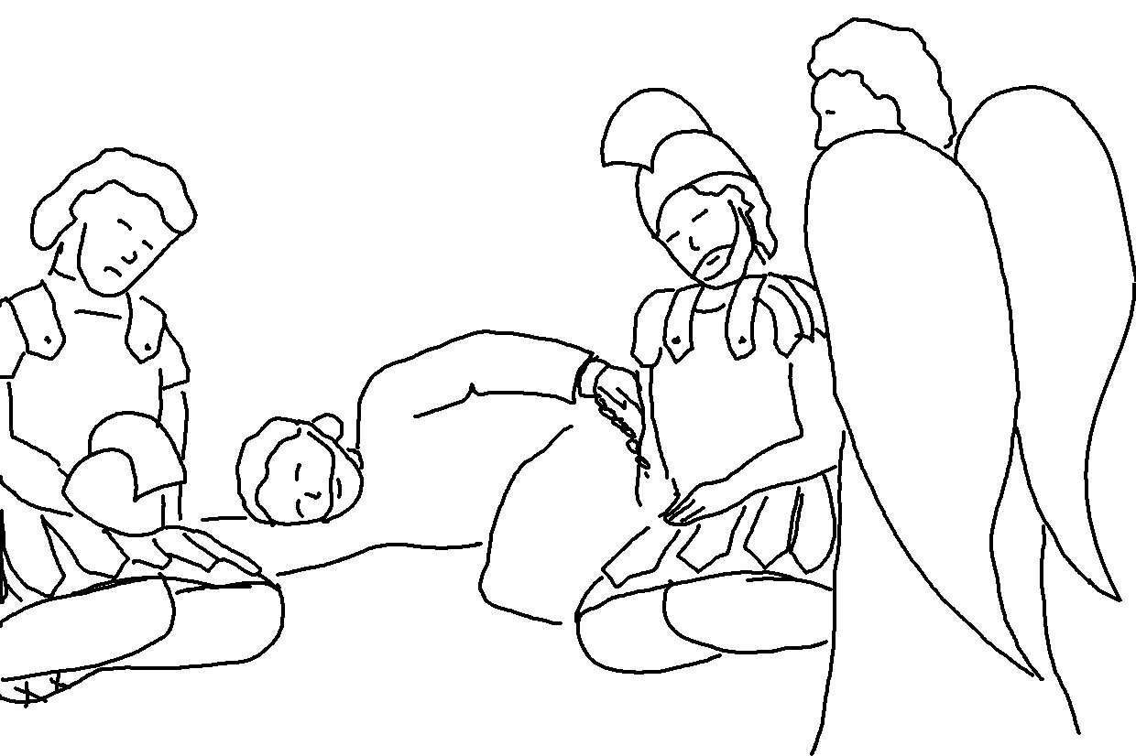
Keep on _ _ _ _ _ _, and you will receive what you ask for.
Keep on _ _ _ _ _ _ _, and you will _ _ _ _.
Keep on knocking, and the door will be opened to you.
Acts 7:7_{NLT}

